Sunday, September 22nd, 2019 @ 10:00 A.M  God Calls Us Together  St. Timothy’s  2400 Alta Vista Drive  Tel: 613-733-0131 Website: www.sttimsottawa.com  Email: sttimsoffice@on.aibn.com  Minister: Rev. Reine Boghos  Email: revreineboghos.sttims@bellnet.ca  Office Administrator: Kay Saunders  Music Director & Organist: Louise Thompson  WELCOME: We gladly welcome all who share in our worship this morning and a special welcome if you are visiting St. Timothy’s. New friends are asked to sign our guest book at the front entrance and/or fill out one of the “We would like” cards found at the back of the Red Psalm books and place on the plate or give to the Minister following the service. Following the service everyone present is invited for coffee hour! If you are new to the area, we invite you to worship with us regularly.  GENERAL ANNOUNCEMENTS  COFFEE HOUR: After church refreshments will be held in the GoForth room today. We have cake to celebrate those with birthdays in July, August, and September. For now, we are trying to use the lower hall as little as possible before the new floor is laid. However, if Sunday is a lovely day, we may move coffee hour outside!  YOUTH CUPCAKE SALE: Youth will be selling cupcakes during Coffee Hour TODAY in support of the Main Hall Floor Replacement Fund. Free will offering.  ST. TIMOTHY’S NEEDS YOUR TALENTS: Please see the notice board and the Time and Talents Survey in the Narthex and return the completed Survey to Joanne Payne or Ernie McArthur.  RE-FLOORING FUNDRAISER: The Stewardship Committee is asking for donations to meet the $30,000 cost, and the fund is presently at approximately $14,000. Thank you!  PLANNED GIVING: Have you sometimes wondered if, and how, you might contribute to the St. Timothy’s legacy by making a long-term gift. If you are interested, please collect one or more of the papers in the Narthex and speak with Joanne Payne or Ernie McArthur.  UPCOMING EVENTS  REVERSE OFFERING REMINDER: For Communion Sunday, the congregation is requested to bring donations for the Heron Emergency Food Centre. After the usual Offering, a second Offering will be taken but instead of placing your gifts on the collection plate, you are invited to remove a slip of paper. On the slip of paper will be a suggested donation for the Food Centre (can of soup, cereal etc.) to be brought to church on Communion Sunday, October 6th. |  | 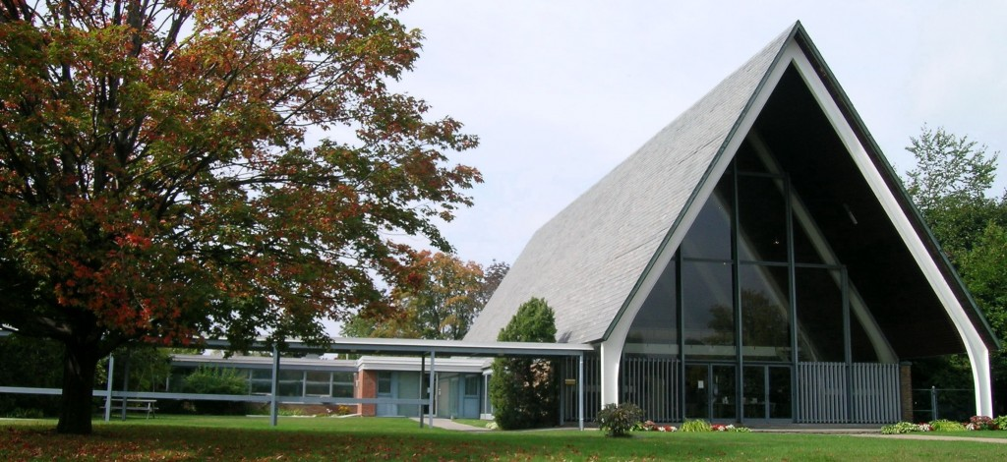  OUR THANKS TODAY  Worship Elder:  Joanne Payne  Scripture Reader:  Michael Orock  Usher:  Sam Asomani  Greeter:  Phoebe Gowdy  Banking:  David Gowdy & James Douglas  Coffee:  The Saahfon Family  Pastoral Care:  Molly Olshefsky  (If you know of anyone in the congregation who is ill or in need of a visit, please let Molly know).  CHURCH OFFICE HOURS:  Tuesdays, Thursdays, and Fridays  9:00am to 12 noon.  MINISTER OFFICE HOURS:  Tuesday and Fridays. Reine will welcome your visit! Please call her at 613-255-6787 to make an appointment.  YOUTH CORNER  TODDLERS & BABIES: Toddler care is provided for children aged 1 (walking) to 3, in the Toddler Room during the Worship Service following Children’s Time. Rocking chairs are available for nursing parents in the Toddler Room; a change table is available in the Youth Room.  SUNDAY SCHOOL:  TODAY - Sunday School Classes  SEPTEMBER 29 – Sunday School Classes  JUNIOR YOUTH:  TODAY – Selling Cupcakes  OCTOBER 20 – Youth Mission Walkathon  SENIOR YOUTH:  OCTOBER 7 – Pizza & Devotions

COMMUNITY  PRESBYTERY OF OTTAWA’S ANNUAL YOUTH RETREAT: Saturday, September 28th, 9:00 A.M Will take place at Gracefield Christian Camp & Retreat Centre; we’re taking advantage of the season change to celebrate changes in the lives of our youth!  Details: Open to youth Grades 6 and up.  Leaving: For Gracefield from St. Paul’s Presbyterian Church’s parking lot (971 Woodroffe) Sat, Sept 28th 9:00 A.M.  Arriving back: at St. Paul’s parking lot on Sun, September 29th 5:00 P.M.  To register (Or for more information) – Contact your youth leader or Minister, or Rev. Cheryl Gaver at cgaver@cogeco.ca.  REFORMATION RALLY: The annual Reformation Rally, organized by some local Presbyterian and Christian Reformed churches, is scheduled for Sunday, October 27th, 2019 at 7pm at St. Paul’s Church, 971 Woodroffe Ave. The guest speaker this year is the Rev’d Dr. J. Kevin Livingston, who is Professor of Pastoral Ministry at Tyndale Seminary, Toronto, and Minister of Clairlea Park Presbyterian Church, Toronto.  CHURCH GROUPS:  AFRICAN CHORUS: Join us for practice Sunday, Oct 6th, 11am.  Singers of African spirituals and hymns, we sing special music during the worship service on the second Sunday of the month.  AFTERNOON CRAFT GROUP: Enjoy knitting, crocheting, or other crafts? Join us Mondays, 2pm. For more information, contact Charlotte Craig or Helen Lee.  MONDAY BIBLE STUDY: Monday, Sept 23, 7pm. Led by Mike Powell. Currently studying Abiding in Christ. All are welcome!  NOT SO YOUNG ADULT GROUP: Sunday, Oct 13th, 11am. For ages 20 to 40. Join us for a time of fellowship, devotion and praise and a light lunch.  ST. TIMOTHY’S CHOIR: Sundays 9am. Led by our Music Director, we lead the congregation in praise music every Sunday worship.  WEDNESDAY BIBLE STUDY: Led by Mike Powell. Currently studying Self-Esteem. All are welcome! |  | WORSHIP SERVICES  October 6th – Communion Sunday  SESSION & COMMITTEE MEETINGS:  Stewardship:  Chair- Ernest McArther  Tues Sept 24th, 5:30pm  Worship:  Chair- Asliena Ginting  Tues Sept 24th, 7pm  Mission & Outreach:  Chair- Nic Larouche  Thurs Sept 26th, 6:30pm  Board of Managers:  Chair – David Gowdy  Tues Oct 1, 7pm  Christian Education:  Chair – Nic Larouche  Thurs Oct 3, 6:30pm  Fellowship:  Chair- Phoebe Gowdy  Thurs Oct 10th, 1pm @ Clara Stel’s place  Clerk of Session:  Chair - Ken Saah Fon  Tues Oct 15th, 7pm

